Q1. Write a java program to find largest element from the Array

Array Elements: 100 20 200 30 500

Largest Element: 500

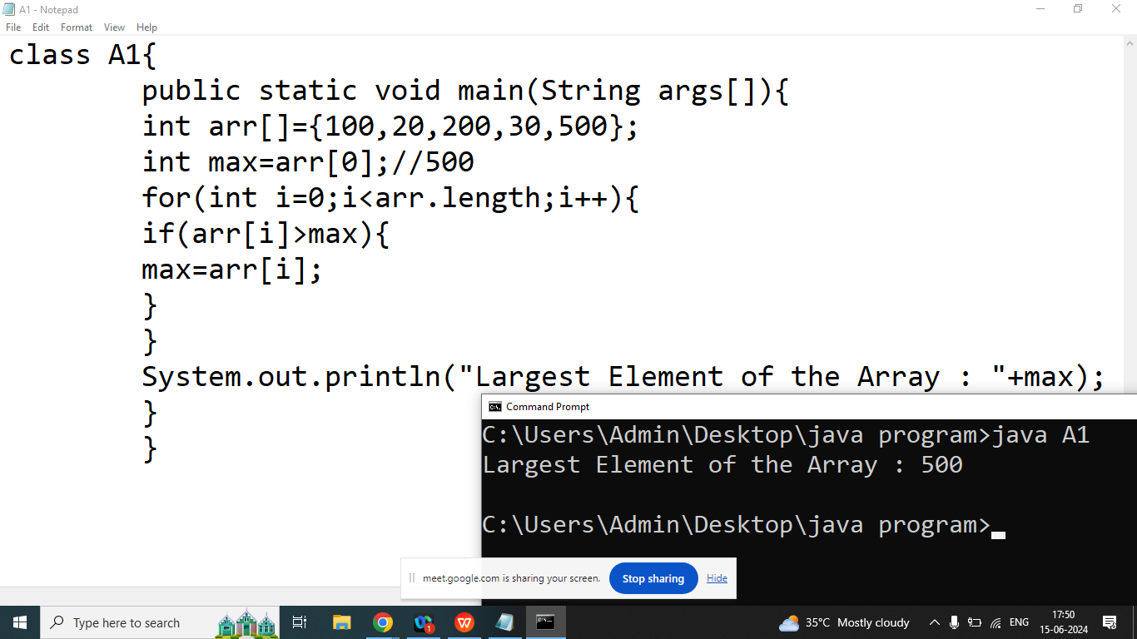

Q1. Write a java program to find smallest element from the Array

Array Elements: 100 20 200 30 500

Largest Element: 20

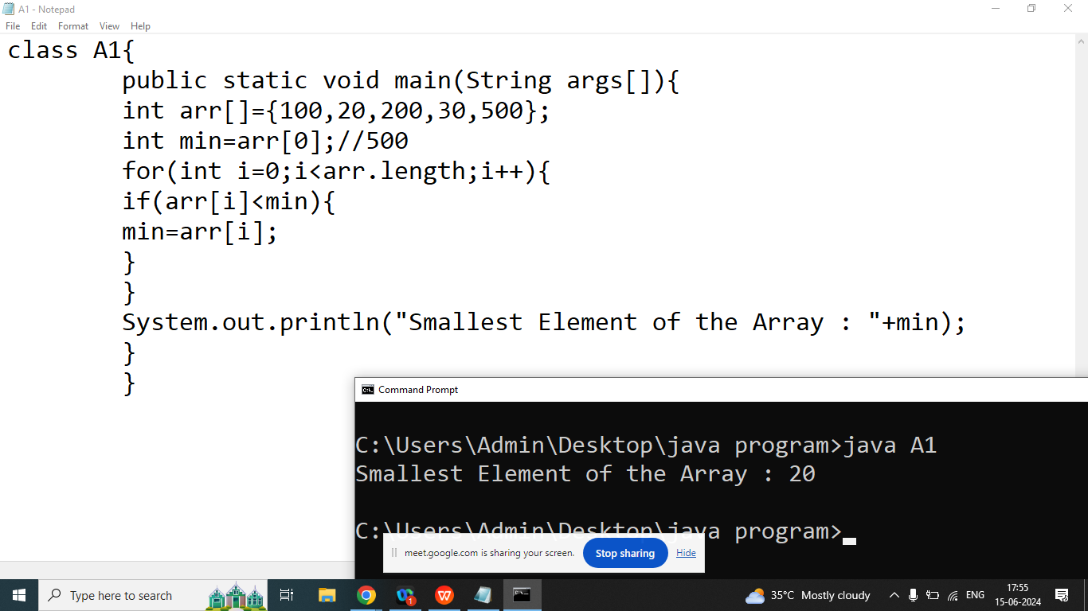

Homework

Q1. Write a java program to find second smallest element from the Array

Array Elements: 100 20 200 30 500

Largest Element: 30

Q2. Write a java program to find second largest element from the Array

Array Elements: 100 20 200 30 500

Largest Element: 200

Q3. Write a java program to convert given decimal number to binary Number.

Enter Any Number: 6

Binary Number: 110

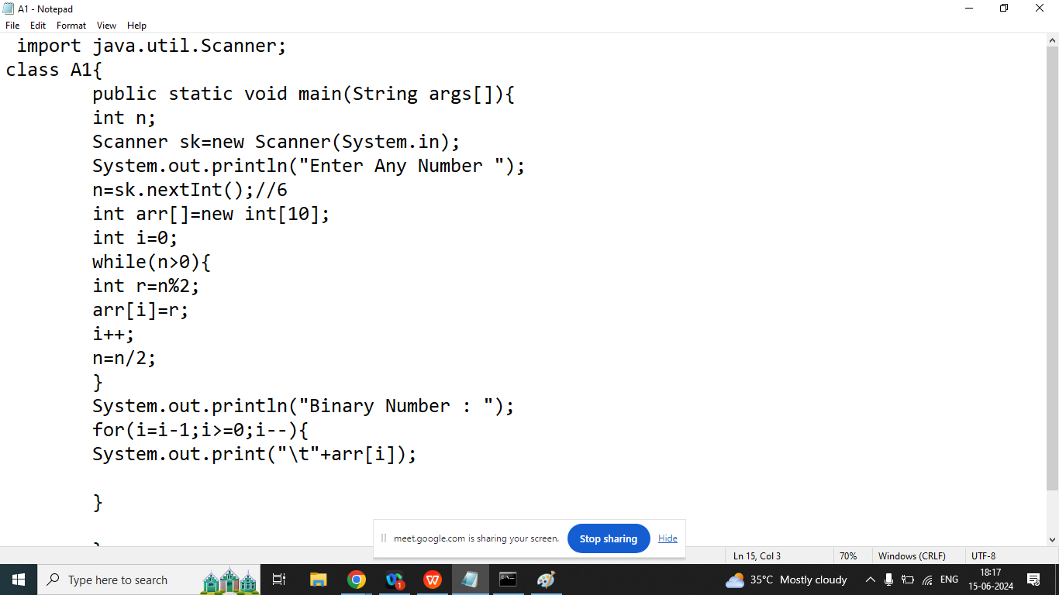

Q3. Write a java program to sort array elements in ascending order

Array Elements: 30 10 20

Before Sorting: 30 10 20

After Sorting : 10 20 30

int a,b,c;

c=arr[i];

arr[i]=arr[j];

arr[j]=c;

class A1{

public static void main(String args[]){

int arr[]={30,10,20,100,40,90,80,50,70,60};

System.out.println("Before Sorting : ");

for(int i=0;i<arr.length;i++){

System.out.print("\t"+arr[i]);

}

//sorting

for(int i=0;i<arr.length;i++){

for(int j=i+1;j<arr.length;j++){

if(arr[i]>arr[j]){

int c;

c=arr[i];

arr[i]=arr[j];

arr[j]=c;

}

}

}

System.out.println("\nAfter Sorting : ");

for(int i=0;i<arr.length;i++){

System.out.print("\t"+arr[i]);

}

}

}